To generate the final Bloodhound .las and xls file insure that you have Gas Chart set up correctly.
At the end of each job you will need to generate a Bloddhound .LAS/.XLS file to send in with your final ML_ log.
Select “Setup” from the Gas Chart Control Box

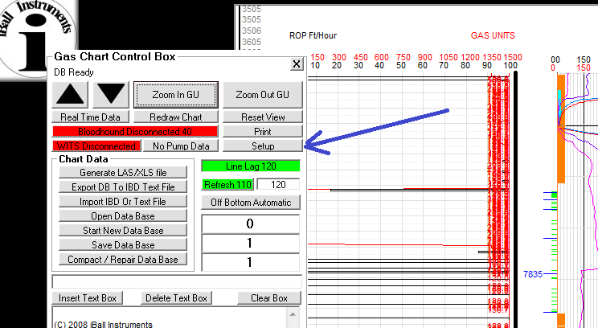

From the Setup menu select the “LAS/XLS” tab

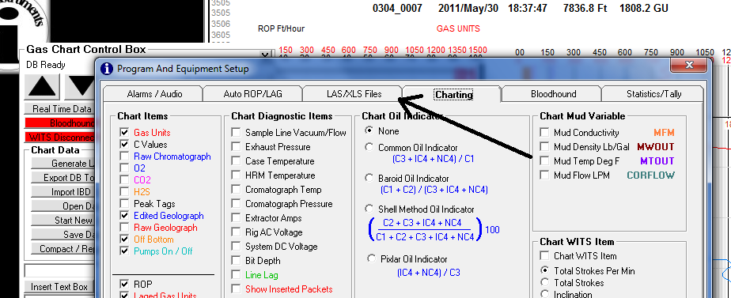

We provide the client with both a lagged and unlagged .las file of each well. By checking “Depth Column is Lagged Depth” for each file type, you will generate the Lagged version. In order to generate an Un-Lagged file remove the check
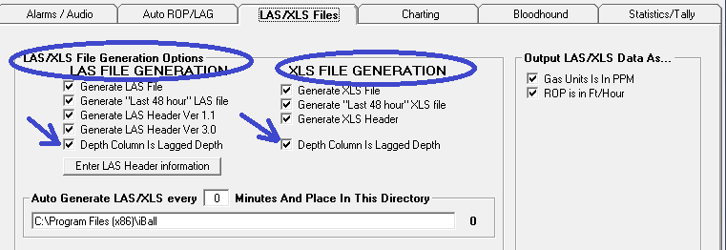
It is also important to insure that the Minimum and Maximum depths reflect the actual depths logged.
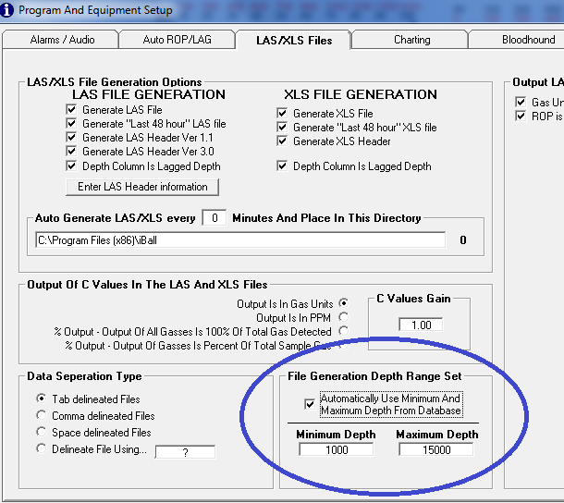

After you have completed the set-up, close it out and select “Generate LAS/XLS file” form the Gas Chart menu. It will open a Window for you to name the file. Be sure to include the name well and which type “lagged or unlagged” of file you are creating.

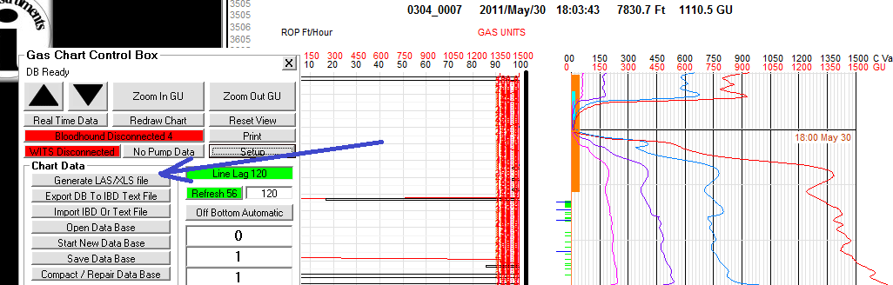
When you select “Generate LAS/XLS file” form the Gas Chart menu it will open a Window for you to name the file. Be sure to include in the name which type “lagged or unlagged” of file you create.
The file you create will be defaulted to the “DB_CUE” folder on the “C Drive”. You can navigate to this folder to select the files you created, and attach them to an e-mail.

