TDS Inc. End of Well Instructions
It is of upmost importance to provide our clients quality and consistency in the product we provide. Standardizing the way our log headers appear is just one step in this effort.
Follow the example below when filling out the header information. Pay special attention to letter case, spacing, symbol use, & general format.
*Exact legal location and API information can be confirmed or found when not provided with original well packet at these websites.
Oklahoma locations: http://imaging.occeweb.com/imaging/OGWellRecords.aspx
Texas locations: http://gis2.rrc.state.tx.us/public/startit.htm

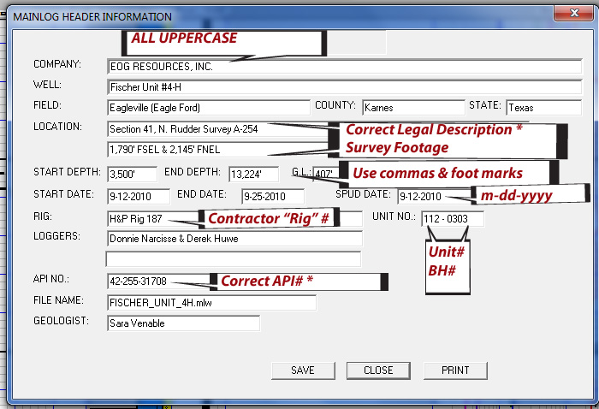
Review all header information for completeness and correctness prior to sending in your final log. It is important that the Final ML_ files be “Print Ready” for distribution
Send”ONLY” the following files with each job worked:
- “Print Ready” Final ML_ (Identify as “Final” in subject area of E-mail)
- Bloodhound .las files (Lagged and Unlagged/RAW)
- Morning and Afternoon reports in .pdf format (Send in zipped folder)
- TDS Daily Drilling summary
It is not necessary to send any .pdf log files of any scale or Mainlog generated .las files.

